1:

Let our signal has bandwidth X,

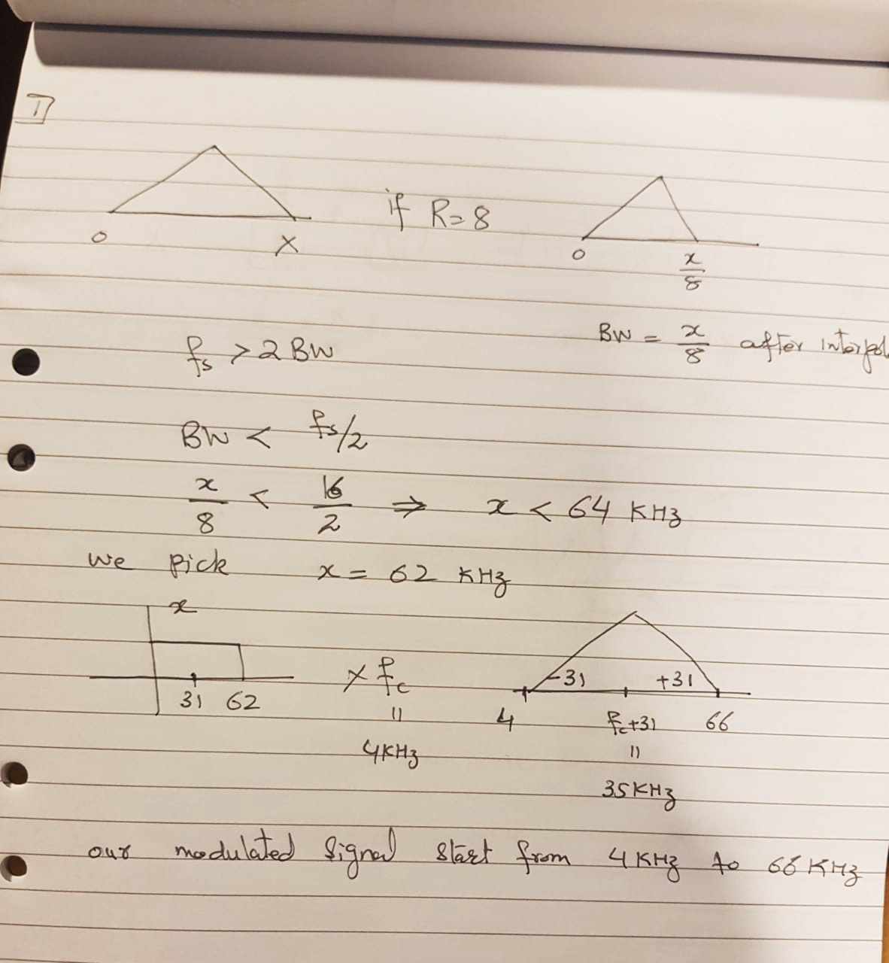

way 2:

The sampling frequency fs=16Khz after interpolation by factor 8 means that the fs before interpolation would be 16/8=2Khz. According to Nyquist theorem fs>2BW🡪BW<fs/2=1Khz. After using modulation at frequency=4Khz the range of frequencies will be from 4Khz to 5Khz.

2: EVM is a measure of how far the received points from the ideal constellation points. If SNR is a finite number instead of infinity the received points will always show some deviation from the ideal constellation points due to the added noise, which means EVM will always show some value even for ideal channels.

3: The channel H is estimated using the pilot OFDM blocks. H is effected by propagation over the physical channel and real part of the signal. The propagation over physical channel affects the signal in magnitude and phase (ideally) but affects in lot of other ways in addition to magnitude and phase if channel is non ideal. Similarly, real part is affected same as imaginary part under the assumption that our channel will affect both similarly since our supposed channel only accepts real signal we will append real part into the imaginary part to achieve a complex signal. Furthermore, H will not be affected by interpolation and decimation if both are equal but if not then they will affect the signal transmitted/ received length but modulation and demodulation will not affect H.

4: We can only discard real or imaginary part of the signal when channel effects both signals with equal contributions. Since in over case the channel is a real channel then discarding imaginary part will not affect received signal because we will just append that real part as imaginary part.

$$Z=Z_{r}+j Z_{i}$$

$$Z_{r}=\frac{1}{2}(Z+\overline{Z})$$

and $$Z_{i}=\frac{1}{2}(Z-\overline{Z})$$

Z can only calculated exactly when $Z_{r}=Z_{i}$ which means channel must effect both components of the signal with same probabilities otherwise if channel behavior is different then we cannot design the received signal in that fashion.

5: We found that Low pass filter characteristics act equal importance for interpolation and decimation stages to remove aliasing affects in the receiving side [1]. Therefore, all the four factors are important in the same way for both stages.

1. The phase linearity is at top for interpolation and decimation, since having non linearity we cannot estimate o/p accurately because the signal's shape changes rapidly, we can't preserve the signal's components and if we can’t perverse signal then passband ripple, stopband attenuation and transition band width became of no use.
2. The transition bandwidth takes the 2nd position for both stages, because this attenuation can cause ISI because it widened the received signal and its less important than 1 because ISI can be eliminated by using other techniques but signal's modified shape cannot be recovered easily.
3. Both passband ripples and stopband attenuation are equally important for both stages, because they are linked with an inverse relation. Decreasing one will increase other. However, there importance can be defined having the prior specified filter characteristics, then we can design the filter using whose requirements.

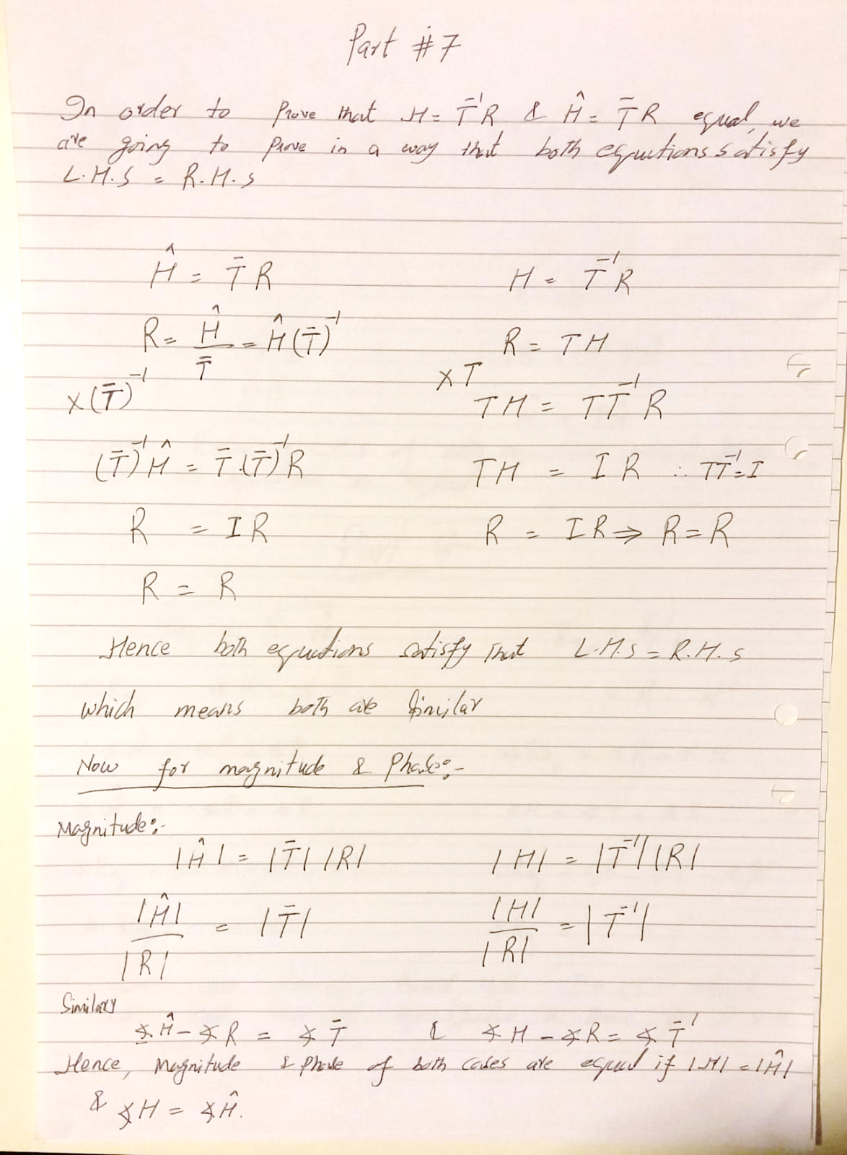

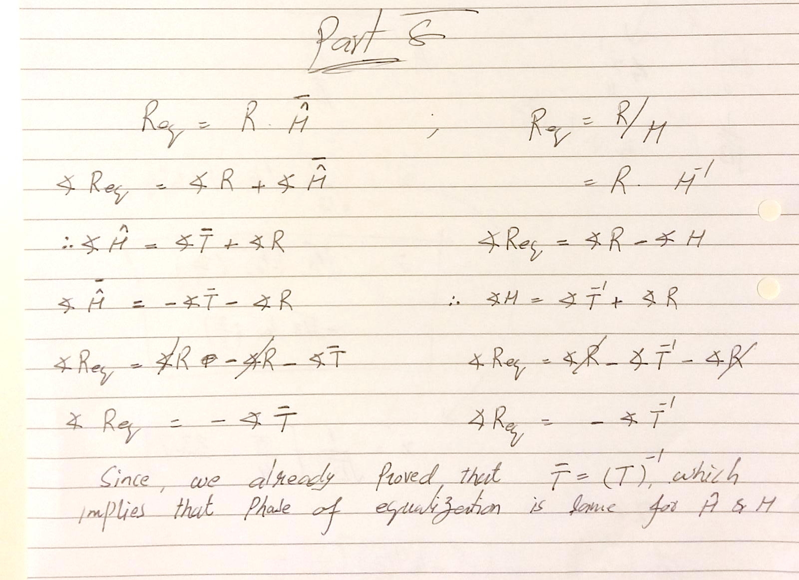

Part 9:

Part 10:

[1] Page 18, “project detail”.